Assignment-3.5

Name: U.Akhil
HT.No: 2303A51704
Batch- 24
Question 1: Zero-Shot Prompting (Leap Year Check)
Write a zero-shot prompt to generate a Python function that checks whether a given year is a leap year.
Week2 -
Task:
- Record the AI-generated code.
- Test with years like 1900, 2000, 2024.
- Identify logical flaws or missing conditions.
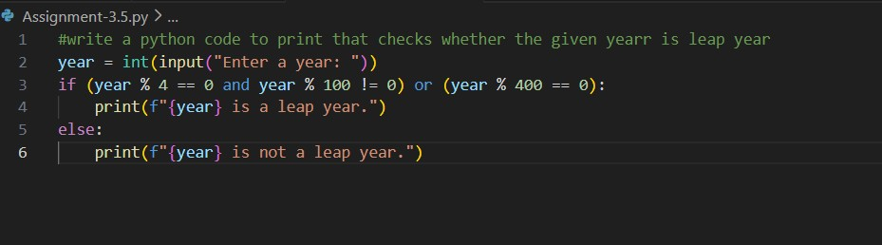
Output:
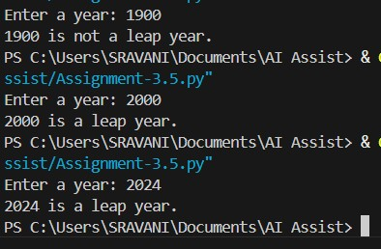

Question 2: One-Shot Prompting (GCD of Two Numbers) Write a one-shot prompt with one example to generate a Python function that finds the Greatest Common Divisor (GCD) of two numbers.
Example:
Input: 12, 18 → Output: 6
Task:
- Compare with a zero-shot solution.
- Analyze algorithm efficiency.
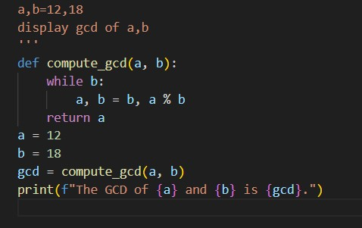
Output:
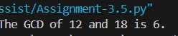

Question 3: Few-Shot Prompting (LCM Calculation)
Write a few-shot prompt with multiple examples to generate a Python function that computes the Least Common Multiple (LCM).
Examples:
- Input: 4, 6 → Output: 12
- Input: 5, 10 → Output: 10
- Input: 7, 3 → Output: 21
Task:
- Examine how examples guide formula selection.
- Test edge cases.
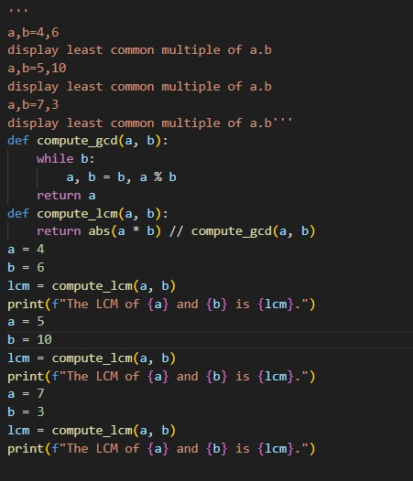
Output:
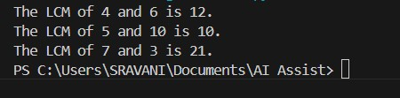
Question 4: Zero-Shot Prompting (Binary to Decimal Conversion) Write a zero-shot prompt to generate a Python function that converts a binary number to decimal.
Task:
- Test with valid and invalid binary inputs.
- Identify missing validation logic.
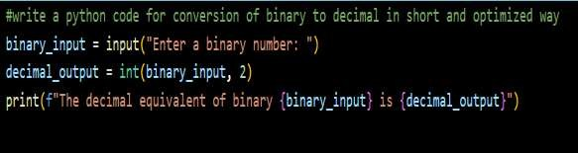
Output:
Question 5: One-Shot Prompting (Decimal to Binary Conversion) Write a one-shot prompt with an example to generate a Python function that converts a decimal number to binary.
Example:
Input: 10 → Output: 1010
Task:
- Compare clarity with zero-shot output.
- Analyze handling of zero and negative numbers.
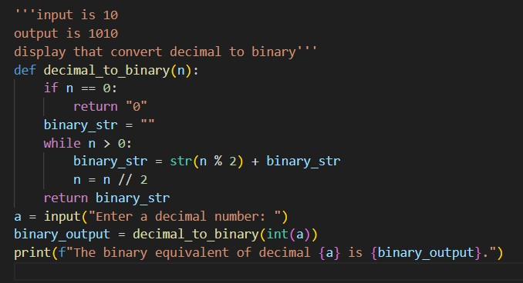
Output:
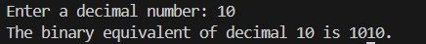

Question 6: Few-Shot Prompting (Harshad Number Check)
Write a few-shot prompt to generate a Python function that checks whether a number is a Harshad (Niven) number.
Examples:
- Input: 18 → Output: Harshad Number
- Input: 21 → Output: Harshad Number • Input: 19 → Output: Not a Harshad Number
Task:
- Test boundary conditions.
- Evaluate robustness
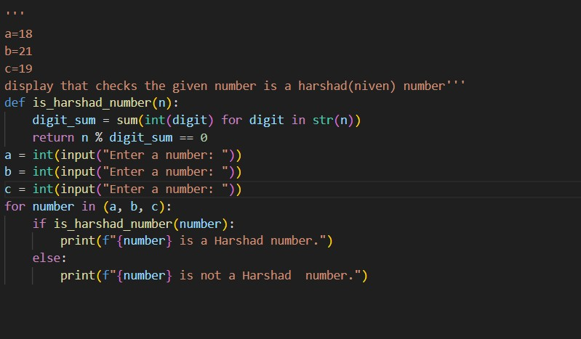
Output:
